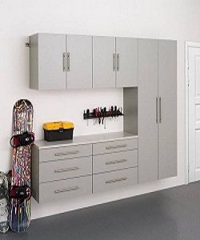

Storage Cabinet

$183.00

Availability: In stock

### Description

Silver Composite steel Garage. Built with heavy-duty 24-guage steel for added strength, the scratch and stain resistant powder-coat paint finish protects the cabinets from everyday heavy-use. Full length integrated handles allow you to quickly and easily access your gear, and adjustable steel shelves give you the flexibility to store items of all sizes, while fully-lockable doors ensure that your tools stay safe. A rugged worktop gives you the room you need for crafts, and home repairs. All fixed cabinets are designed to be secured to a wall to ensure safety. Get organized, and simplify your life, with Silver Composite steel Garage.